Do real estate prices co-vary with global inflation, interest rate and output growth in USA, Australia, and Canada?

  - Abdul Ghaffar-18139-2545
  - Rumaisa Rashid-18135-2275
  - Saad-uz-Zaman-17972-2545
  - Applied Econometrics I

Introduction

It is believed that real estate prices of any country will be associated with its economy, especially, with its macroeconomic variables. In addition to this, there have been numerous studies in this area as well. Similarly, the objective of this research is to find the effect of GDP Output Growth Rates, Inflation, and Real Interest Rates on the Housing Prices (RHPI) of USA, Australia and Canada, over a period of 46 years, through various econometric models. The motivation to take into account the changes in housing prices is due to its growing worth and demand. According to an estimate of U.S Census Bureau (St Louis FED), housing prices in the US have risen from an annual average of $44,600 in 1975 to $383,000 in 2019, making up an increase of 77% (adjusted by inflation). Prior to the global financial crises of 2008, the prices of houses were subsequently increasing, they suffered in 2008 but got back to their pre crises rate in 2013, gradually rising up from then again till 2018, and then slightly decreasing in 2019. This general rise in housing prices, as well as an opportunity of acquiring long-term revenue throughout the years, has motivated people to develop a mindset that buying property especially houses are a safe and profitable investment therefore increasing its demand in an economy. When people start to invest more in property, a larger proportion of the GDP is now constituted of real estate. Therefore, raising the question that whether changes in macroeconomic variables such as interest rates, inflation, and the GDP itself has an effect on housing prices or not.

Literature Review

Before conducting the analysis it is important to take into account previous researches carried out to answer similar questions. This will not only intensify the importance of our study, as well as help us in understanding the relationship between the variables and the subject. Chan and Woo (2013) kept Hong Kong into observation and concluded in their analysis that growth in GDP causes a long-run increase in the real prices of houses using the casualty test and IRFs. Similarly, Xu and Tang (2014) in their study of finding the determinants of housing prices in the UK through the co-integration approach and error correlation model determined that GDP, credit, construction expenses, interest rates, and unemployment rate have a positive impact on the housing prices.

Though, it can be argued that as real estate takes time for construction, how can its consumption and prices go hand in hand? It is highly possible that when housing prices rise, people invest largely into it, but, when the property is finally constructed, real estate prices might have been fallen down, decreasing its consumption as well its share in the GDP, this is called the housing-wealth effect. This effect will decrease the effect of macroeconomic variables on housing prices. However, it is repeatedly argued that housing wealth effect has a very less effect. (Attanasio and Weber, 1994; Attanasio, Blow, Hamilton, and Leicester, 2005) While the bank of England proclaimed that the housing wealth effect is insignificant. (Benito, Thompson, Waldron, and Wood, 2006)

Furthermore, observing a cross country analysis of seven advanced economies, Vogiazas & Alexiou (2017) concluded that real GDP, real interest rate, and bank credit growth effect housing prices fundamentally. On the other hand, an interesting study by Tripathi (2020) on the data of 43 countries over a time period of 47 years using random-effect models and generalized least square estimation techniques, determined that while GDP output growth rate and inflation has positive impact on the housing prices, but, real interest rate has no effect on the subject. Similarly, Ouma (2015) used the ANOVA test of significance to find out the effects of macroeconomic variables on real estate prices in Kenya and concluded that when GDP increased in the country, it consequently increased investment in property, leading to an increased supply of houses, decreasing the price of real estate. It also determined a direct relationship between housing prices, inflation and real interest rates.

Methodology:
In this analysis of factors affecting Housing Price Index (HPI), we have used an extensive 45 years of data ranging from 1975 to 2019 (inclusive) for USA, Canada and Australia. A Linear regression model has been used on our annual data of GDP Growth rate (%), Inflation (GDP deflator) (%) and Real interest rate (%). The data has been extracted from sites of The World Bank and Federal Reserve Bank of Dallas. There are 3 different models in our research paper, one for each country, to find the effect of these macroeconomic indicators on HPI. We have carried out different statistical tests, such as Ramsey test and Global f-test , to verify the authenticity as well as the specification of our model. Further, we have also included Residual Normality Test to identify whether the error terms are normally distributed or not. Lastly, we have used the Chow test to check for parameter stability and have chosen to break the data at the year 2007 to check if the parameters of our model are significant pre and post the global financial crisis 2007-2008.

USA
  - Plot of GDP Growth, HPI, Inflation, and Real Interest rate of USA against time
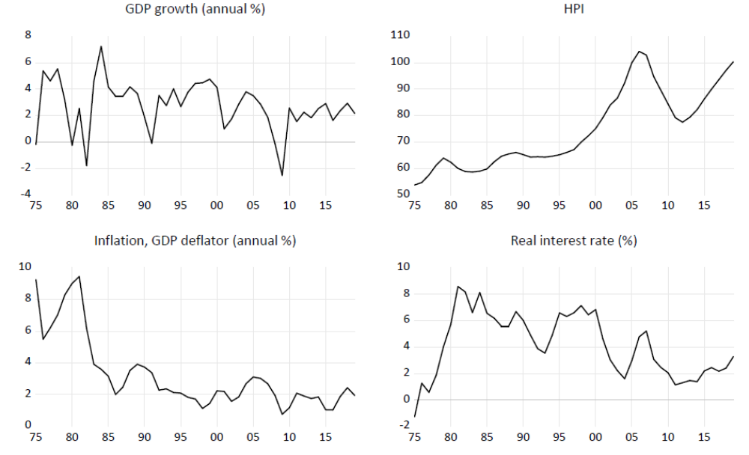
The General trend shows that Housing price Index shows a gradual increase from the years 1975 till 2007 then suffers a steep decline in 2007 to 2008 going below 80 and then starts to rise again in 2012 at a steady rate. GDP growth and Inflation (%) also hit their minimum at this point between 2007 and 2010 when Housing price suffers a steep decline. Interest rates seem to rapidly increase from 1975 to 1980 and then experience steep decline during the Global world recession and gradually start increasing again after 2010.

  - Linear Regression Model
  - HPI = β1 + β2(GDP Growth) + β3(Inflation) + β4(Real Interest rate) + ε
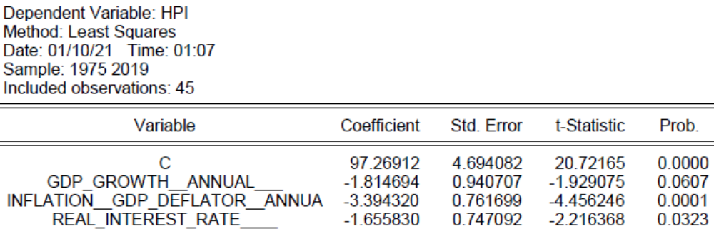
B1: With GDP Growth, Inflation rate and real interest rate at 0, the value of housing price index is 97.3
B2: Keeping inflation rate and real interest rate as constant, 1 percentage point increase in real GPD growth causes HPI to decrease by 1.815 units.
B3: Keeping GDP growth and real interest rate as constant, 1 percentage point increase in Inflation rate causes HPI to decrease by 3.394 units.
B4: Keeping inflation rate and GDP growth as constant, 1 percentage point increase in real interest rate causes HPI to decrease by 1.656 units.
The p-value of all coefficients other than B2 is less than the level of significance (5% = 0.05) thus indicating that they have some effect on the housing price index.
R-squared value is 0.429 thus 42.9% variation in data is explained by the model.

  - Residual Normality Test
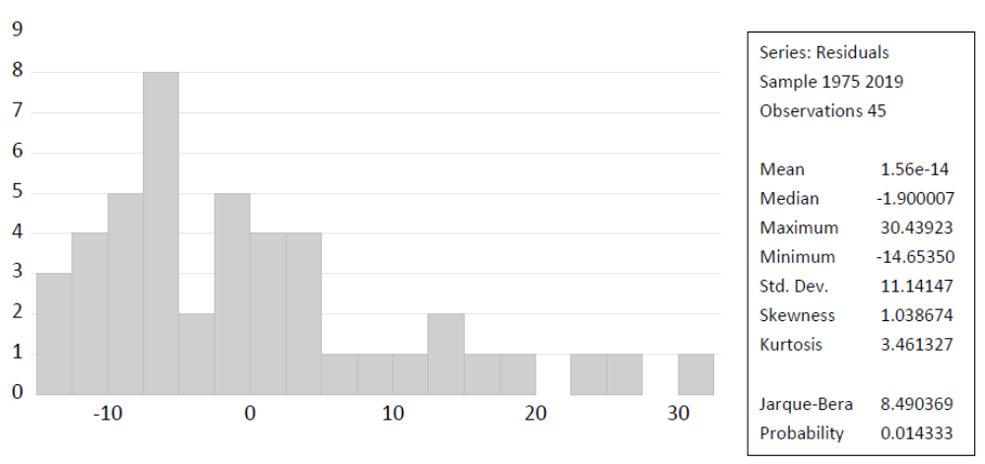
To verify the assumption that the error terms are normally distributed , we apply the Jarque-Bera test , testing whether the skewness and kurtosis of the error terms matches that of a normal distribution. The test p-value is less than 0.05, thus we interpret the error terms are not normally distributed.
  - Ramsay RESET
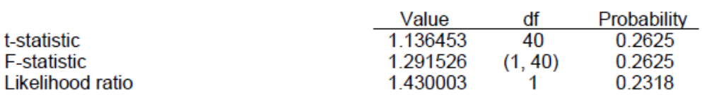
To test for misspecification due to incorrect functional form or omitted variables, we conduct Ramsey RESET . Our P value is greater than 0.05 thus indicating the model is not mis-sepecified.

  - Chow Test
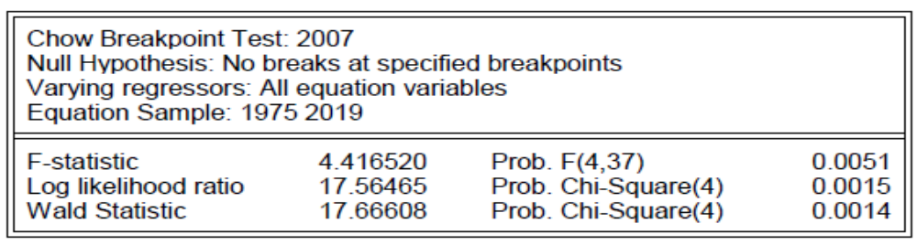
We observe a spike in housing price index around 2007 thus we keep it as our structural break point and see whether the regression model fits the data better after the sudden spike. The p-value comes out as less than 0.05 thus we can conclude there is a significant break at our specified break point.

Canada
  - Plot of GDP Growth, HPI, Inflation and Real Interest rate of Canada against time
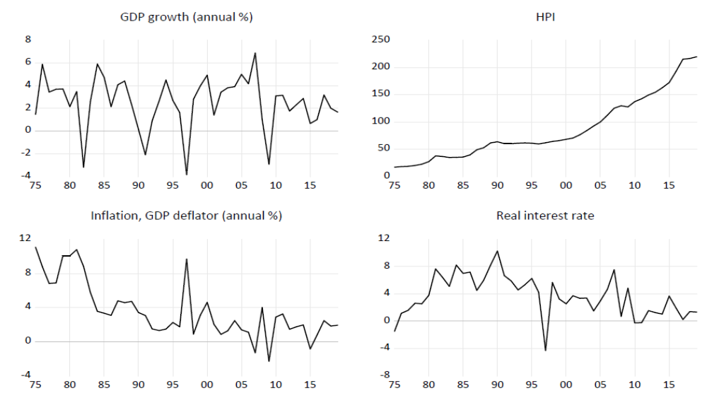
Housing Price Index shows a steady increase from in the time period 1975 to 2019 and doesn't seem to be influenced by other Macroeconomic indicators. GDP and interest rate seem to fluctuating through the years. Inflation shows a decreasing pattern however a sharp increase can be observed around 1995 to 1997 while in that same time frame a steep drop can be seen in the Real interest rate and GDP. GDP growth reached its peak in 2007 then suffered a dramatic drop around which time inflation also hit its lowest level.
  - Linear Regression Model:
  - HPI = β1 + β2(GDP Growth) + β3(Inflation) + β4(Real Interest rate) + ε
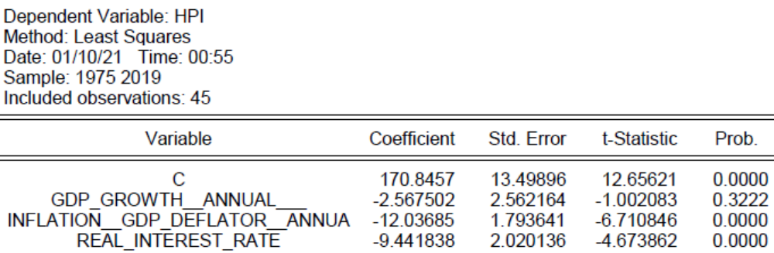
B1: With GDP Growth, Inflation rate and real interest rate at 0, the value of housing price index is 170.8
B2: Keeping inflation rate and real interest rate as constant, 1 percentage point increase in real GPD growth causes HPI to decrease by 2.567 units.
B3: Keeping GDP growth and real interest rate as constant, 1 percentage point increase in Inflation rate causes HPI to decrease by 12.037 units.
B4: Keeping inflation rate and GDP growth as constant, 1 percentage point increase in real interest rate causes HPI to decrease by 9.442 units.
The p-value of all coefficients is less than the level of significance (5% = 0.05) thus indicating that they have some effect on the housing price index.
R-squared value is 0.589 thus 58.9% variation in data is explained by the model.

  - Residual Normality Test
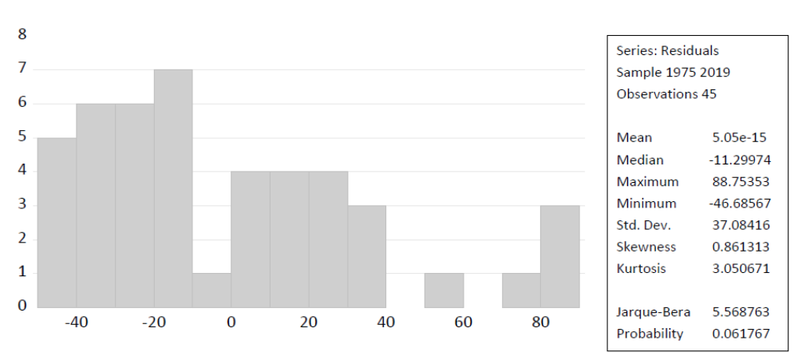
To verify the assumption that the error terms are normally distributed, we apply the Jarque-Bera test , testing whether the skewness and kurtosis of the error terms matches that of a normal distribution. The test p-value is greater than 0.05, thus we interpret the error terms are normally distributed.
  - Ramsay RESET
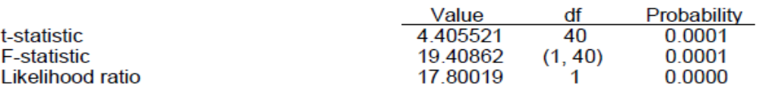
To test for misspecification due to incorrect functional form or omitted variables, we conduct Ramsey RESET. Our P value is lesser than 0.05 thus indicating the model is missepecified.

  - Chow Test
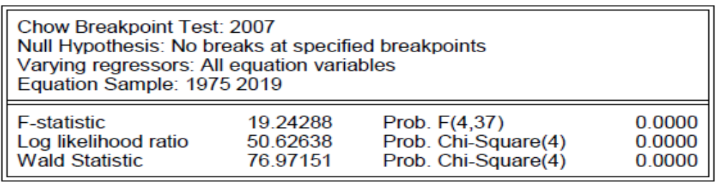
We observe a spike in housing price index around 2007 thus we keep it as our structural break point and see whether the regression model fits the data better after the sudden spike. The p-value comes out as less than 0.05 thus we can conclude there is a significant break at our specified break point.

Australia
  - Plot of GDP Growth, HPI, Inflation and Real Interest rate of Australia against time (0 = 1975 till 45 = 2019)
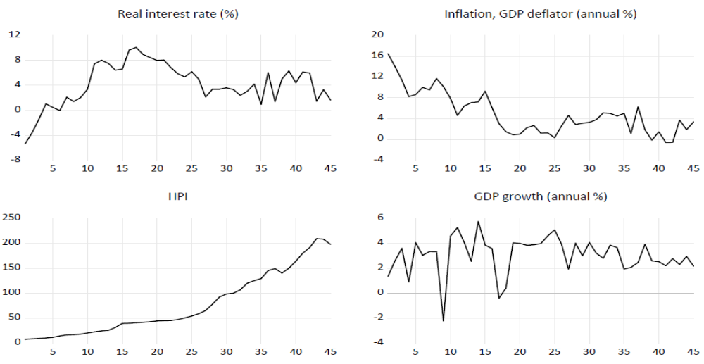
Housing Price Index shows a gradual increasing pattern till 2000 after which grows at an increasing rate with two minor drop observed from 2007 to 2010 and after 2015. A soaring increase in real interest rate is observed till 1990 after which it begins to gradually decrease till 2005 after which a fluctuating is seen. Overall Inflation shows a decreasing pattern while a few undulations can be appreciated where the lowest point is observed between after 2015. GDP growth is seen to rapidly oscillate till 1995 after which some stability was observed for the next 5 years. Following this, smaller fluctuations can be seen as compared to the previous pattern.
  - Linear Regression Model:
HPI = β1 + β2(GDP Growth) + β3(Inflation) + β4(Real Interest rate) + ε
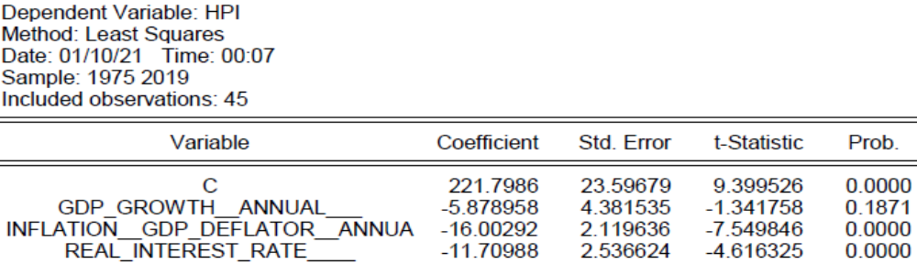
B1: With GDP Growth, Inflation rate and real interest rate at 0, the value of housing price index is 221.8
B2: Keeping inflation rate and real interest rate as constant, 1 percentage point increase in real GPD growth causes HPI to decrease by 5.879 units.
B3: Keeping GDP growth and real interest rate as constant, 1 percentage point increase in Inflation rate causes HPI to decrease by 16.003 units.
B4: Keeping inflation rate and GDP growth as constant, 1 percentage point increase in real interest rate causes HPI to decrease by 11.71 units.
The p-value of all coefficients is less than the level of significance (5% = 0.05) thus indicating that they have some effect on the housing price index.
R-squared value is 0.587 thus 58.7% variation in data is explained by the model.

  - Residual Normality Test
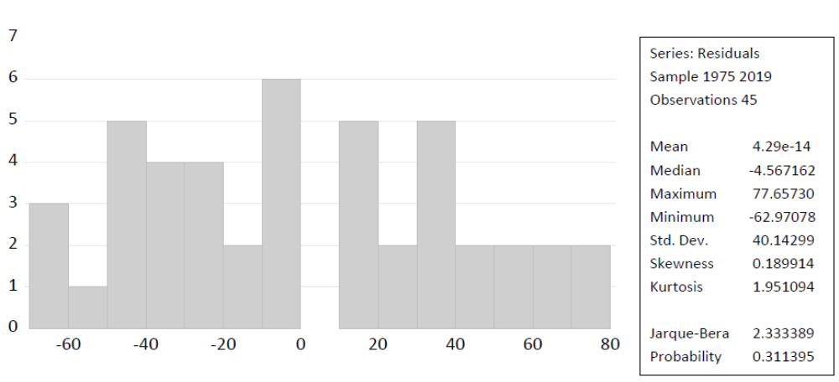
To verify the assumption that the error terms are normally distributed , we apply the Jarque-Bera test , testing whether the skewness and kurtosis of the error terms matches that of a normal distribution. The test p-value is greater than 0.05, thus we interpret the error terms are normally distributed.

  - Ramsay RESET
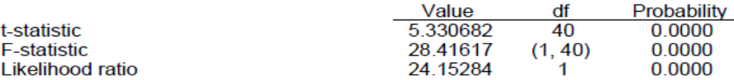
To test for misspecification due to incorrect functional form or omitted variables, we conduct Ramsey RESET . Our P value is lesser than 0.05 thus indicating the model is missepecified.

  - Chow Test
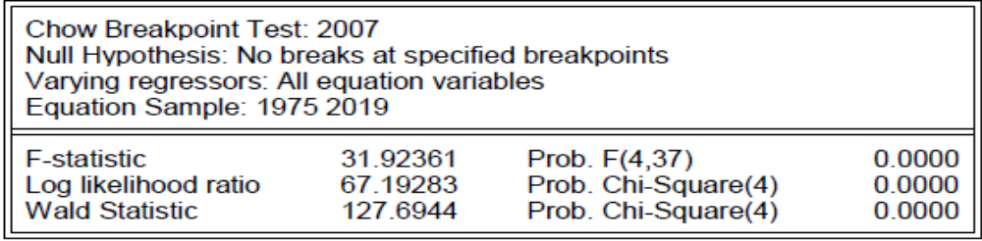
We observe a spike in housing price index around 2007 thus we keep it as our structural break point and see whether the regression model fits the data better after the sudden spike. The p-value comes out as less than 0.05 thus we can conclude there is a significant break at our specified break point.

Conclusion

We conducted this secondary research to assess the effects of economic indicators like GDP growth rate, inflation as GDP deflator and real interest rate on the housing price of 3 different countries namely, USA, Canada, and Australia. We employed a regression model and conducted tests Ramsey's RESET, the Chow test, Residual Normality test and Jarque-Bera test. Major results of our study indicate that the macroeconomic indicators that we chose all have a negative effect on Housing price index and they are all statistically significant.

References:
Attanasio, O., L. Blow, R. Hamilton, and A. Leicester (2005). Booms and Busts: Consumption, HousePrices and Expectations. Working Paper 05 /24. Institute for Fiscal Studies, London.
Attanasio, O. and G. Weber (1994) (Attanasio, 1994)The U.K. Consumption Boom of the Late 1980s: AggregateImplications of Microeconomic Evidence.Economic Journal, 1994, 104:427, 269–302.
Benito, A., J. Thompson, M. Waldron, and R. Wood. House Prices and Consumer Spending.Bank of England Quarterly Bulletin, 2006, Summer, 142–54.
Chan, H., & Woo, K. (2013). Studying the Dynamic Relationships between Residential Property Prices, Stock Prices, and GDP: Lessons from Hong Kong. Journal of Housing Research, 22(1), 75-90. Retrieved January 11, 2021, from http://www.jstor.org/stable/24862540
Ouma, Amos O, A. (2015). Effect of macroeconomic Variales on real estate prices in Kenya (Unpublished master's thesis). University of Nairobi. Retrieved December, 2015, from http://erepository.uonbi.ac.ke/handle/11295/93547?show=full
Tripathi, Sabyasachi. (2020). “Macroeconomic Determinants of Housing Prices: A Cross Country Level Analysis” Real Estate Finance, 36:4 (2020), 229-238, Wolters Kluwer.
U.S. Census Bureau and U.S. Department of Housing and Urban Development, Average Sales Price for New Houses Sold in the United States [ASPNHSUS], retrieved from FRED, Federal Reserve Bank of St. Louis; https://fred.stlouisfed.org/series/ASPNHSUS
Xu, L. and B. Tang (2014) “On the Determinants of UK House Prices”,International Journal of Economics and Research, 5, 57-64.

